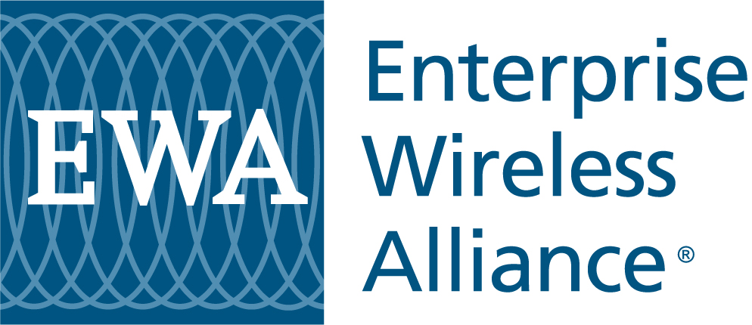 | 8484 Westpark Drive, Suite 630  McLean, VA 22102  Phone: 800 482 8282  Fax: 703.524.1074  www.enterprisewireless.org | Licensing Assistance Office  122 Baltimore Street  Gettysburg, PA 17325  Phone: 800.886.4222  Fax: 717.337.9157

Mobile/Portable-Only License Application

Please complete the following information and return to EWA either by fax to 703.524.1074 or 717 337 9157 by email to customerservice@enterprisewireless.org or by mail to the address above. Contact Customer Service at 800 482 8282 if you have questions or need an EWA Fixed Site Worksheet.

Licensee Administrative Information  Licensee Name ____________________________________________  Corporation Other (Please specify) __________________________  Authorized Licensee Contact ________________________________________  Street Address __________________________________________________  City ___________________________State _________ Zip _______  Phone ___________________________ Fax ___________________________  Email __________________________________________________________  Licensee Tax Identification Number (TIN/EIN) __________________________  FCC Registration Number __________________ ULS Password _____________  Eligibility: _______________________________________________________  Contact _________________________________________________________  Contact Company: ________________________________________________  Phone: ________________________ Email: ___________________________ | System Information  Address of Mobile Operation ________________________________________  (If different than mailing address above)  County ____________________________________________State ________  New Modification (Provide Call Sign) ________________________  Frequency Band VHF (150-174 MHz) UHF (450-470 MHz)  Number of Portables [_____] Number of Channels [_____]  Output Power [_____] Watts ERP [_____] Watts  Emission Designator: 25 kHz 12.5 kHz 6.25 kHz  7K60FXE/FXD 4K00F1E/F1D 11K2F3E 20K0F3E 8K10F1E  Coordinates: ______________________ _N _________________________W  Area of Operation: ___________kilometers County: _______________

Fee Calculation/Method of Payment

   Frequency Selection & Coordination (1-5 Channels) ($110) and FCC Filing Fees ($260) Inclusive 370.00
Additional Channels at $110 (in increments of 1-5 channels) ($100 for EWA Member) ______
Establish FCC Registration Number/ULS Password ($55 Non-EWA Member or $35 EWA Member) ______
Complete Required Notification of Construction ($100 Non-EWA Member or $90 EWA Member) ______
Form 601 - Form Preparation/Completion ($250 Non-EWA Member or $195 for EWA Member) ______
Total Fee: $______
Check Sent/Enclosed Apply Fee To Customer Drawdown Account Reference Number: __________________________
Please charge American Express Master Card VISA
Card Number _________________________________________________ Expiration Date ____________________________________________
Cardholder Name ______________________________________________ Signature _________________________________________________

